POS-eMetrics User Manual

About the developers:

This application is developed by 4 dedicated app developers,

1. Parth Pandey (RA1911003010223)
2. Soham Sakaria (RA1911003010246)
3. Eeshan Dutta (RA1911003010256)
4. Parth Srivastava (RA1911003010228)

We are studying in SRM University, kattankulathur, Chennai currently pursuing undergraduate degree of Bachelors in Computer science and engineering, presently in 3rd year. We are delighted to work with the app and have learned a lot during the process. We have created a user manual to help understand the app.

1. Sign up
2. 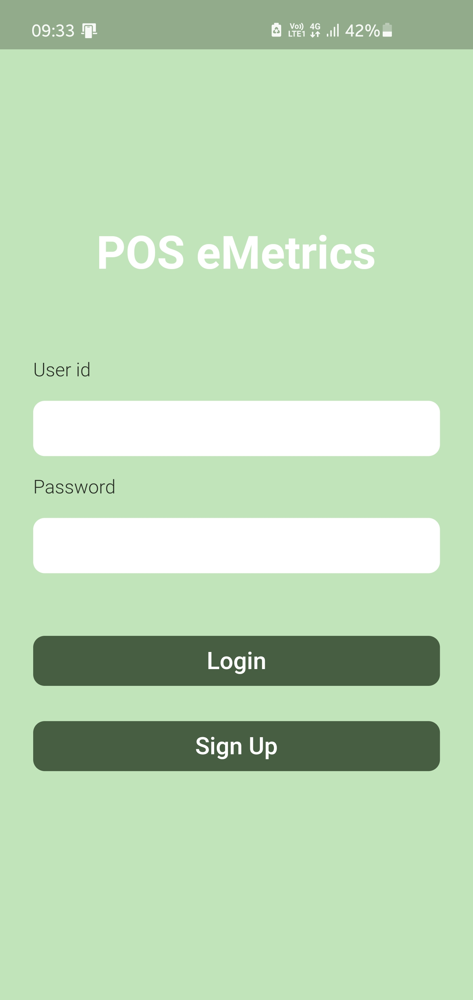Click on the signup button when the app is opened to make a new account on the pos-eMetrics app.
3. Enter your email account along with the password that you want to add to your account, and then click on the sign up button. You will be redirected to the Login screen.

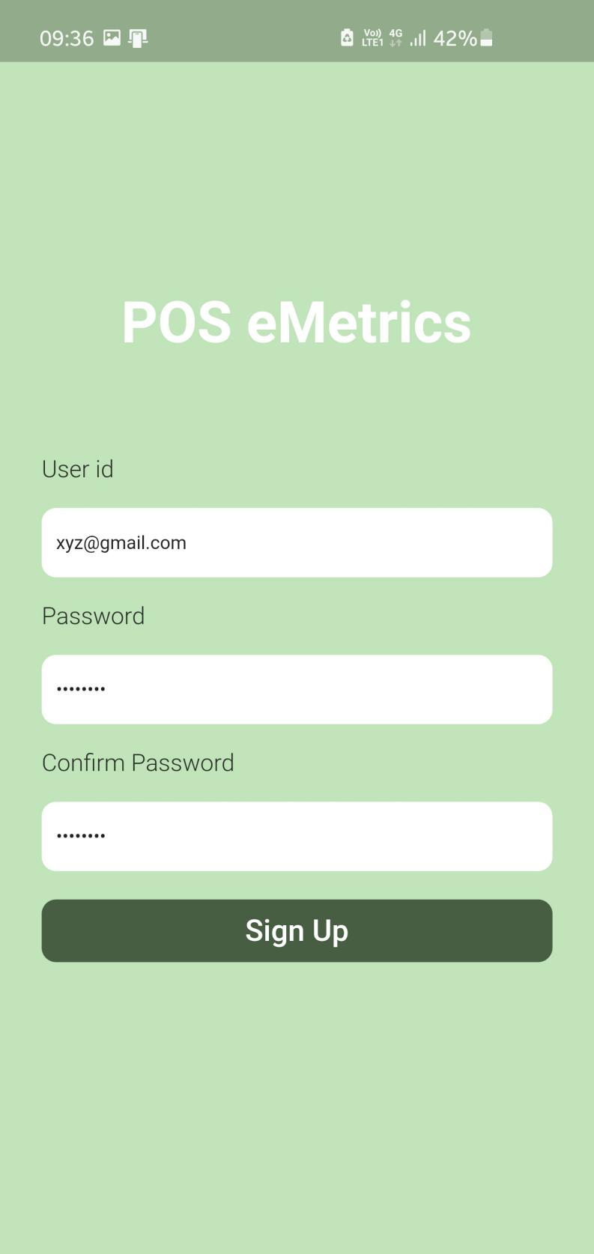

1. Login

Enter the email and the password that was created during the sign up process to login, click on the Login button to login to the app

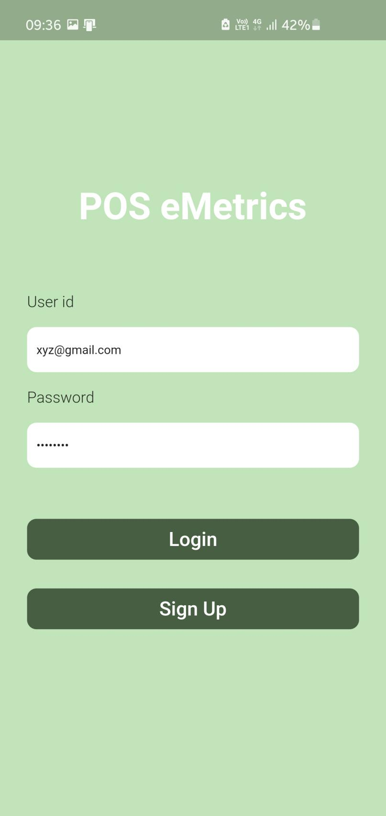

1. Adding an event
2. Click on the ‘+’ button on the bottom right hand of the main screen to add an event to the calendar

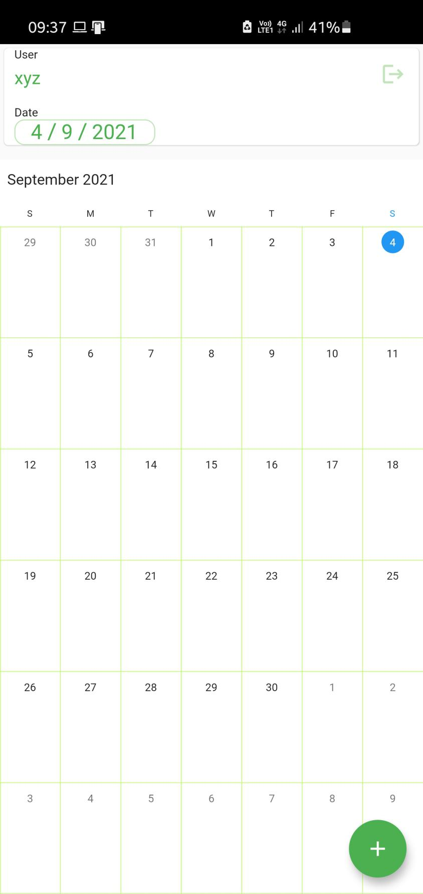

1. Enter the details in the form regarding the event. the details that are marked with ‘\*’ are mandatory to fill. After filling all the details, click on the save button to move forward.

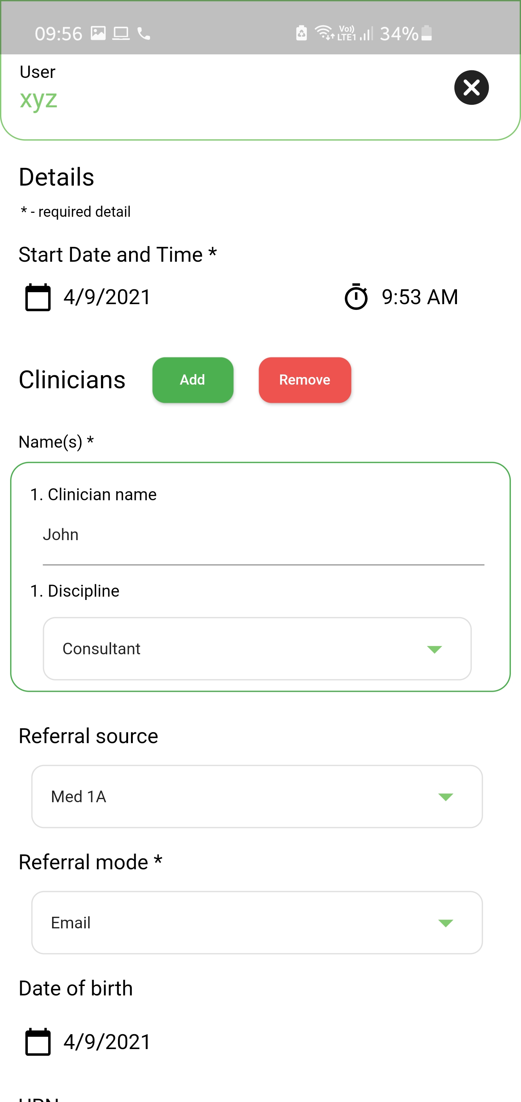

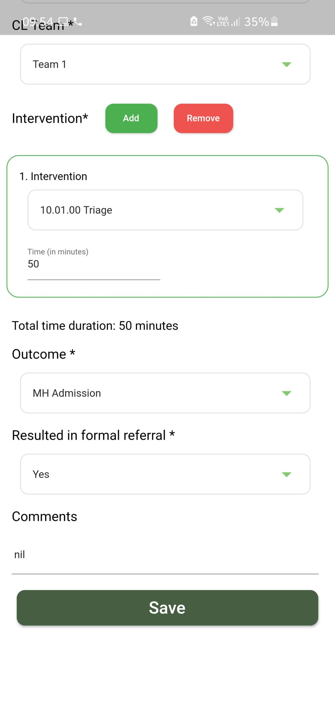

1. After clicking the Save button, a prompt to confirm will show up where you can review the details once and again and make changes if you want. If every detail if confirmed, click on the ‘Confirm’ button to proceed. After confirming, it will automatically redirect to the calendar

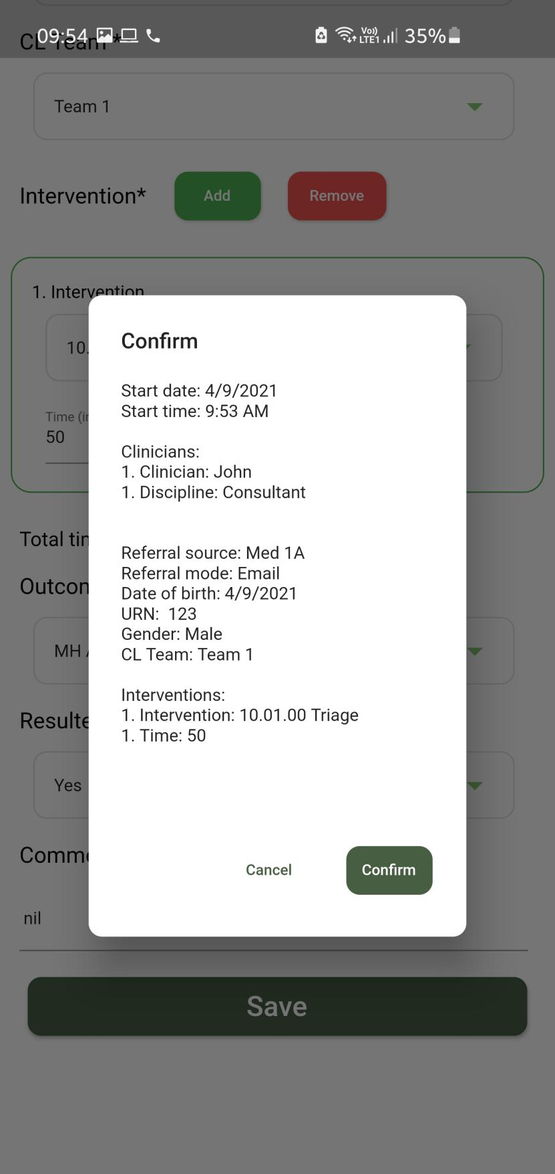

1. Checking/editing an event from the calendar.
2. Long press on the date you want to check the events on.

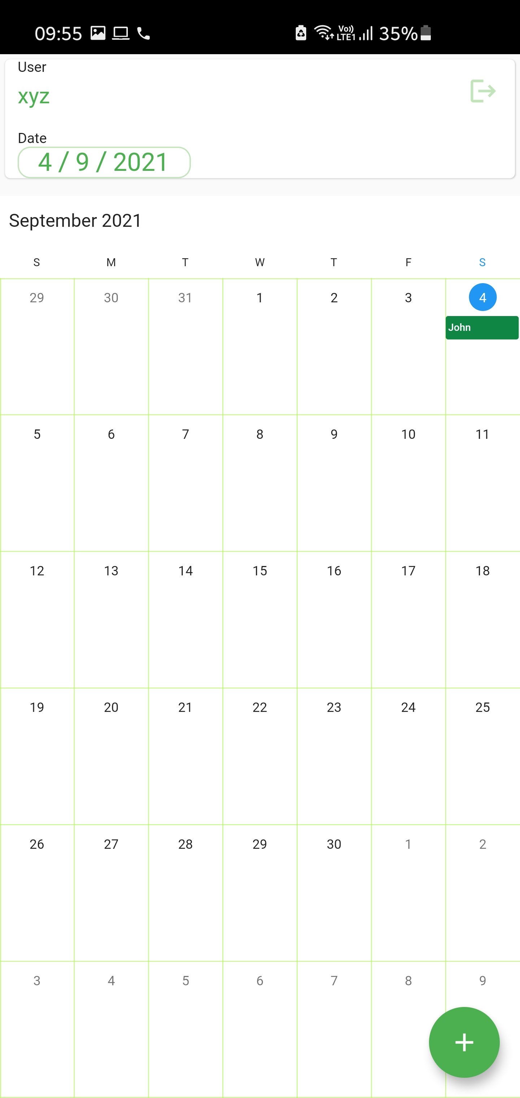

Long Press

1. After long press, a dialog box from bottom will appear with all the events scheduled on that particular date

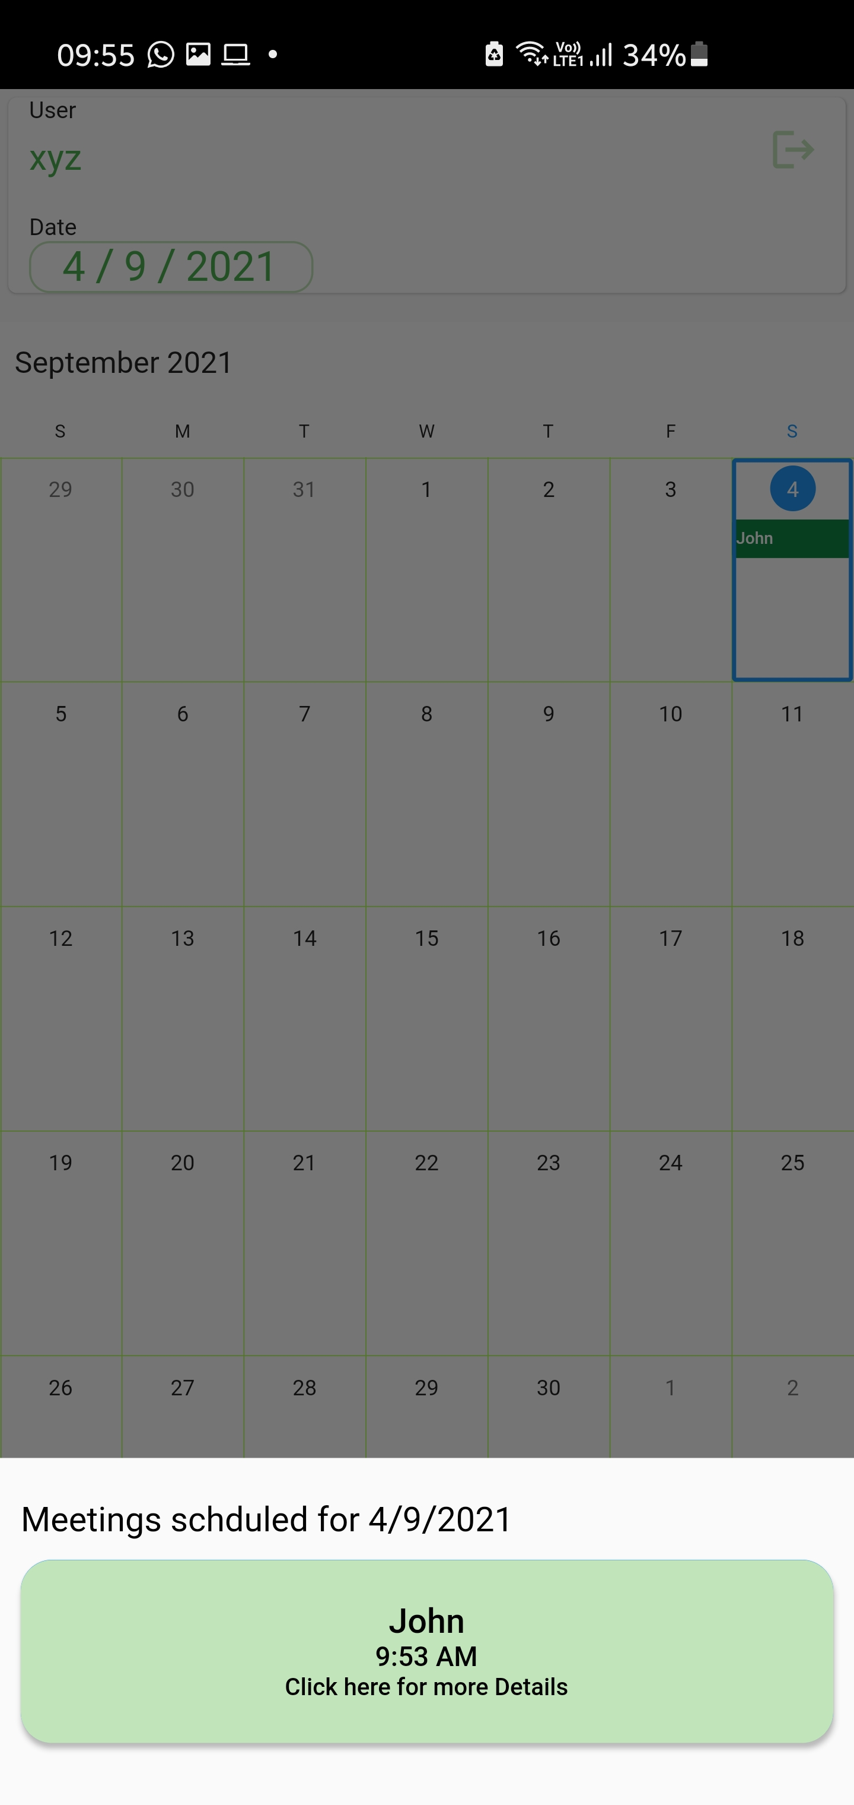

1. Click on the event that you want to edit/check, and the details page will open up.



After finishing, you can save and confirm the changes if you have edited the details or you can click on the cross on the top right hand to go back to the calendar screen.

THANK YOU